Changing the hyperparameters

Optimizer: RMSProp

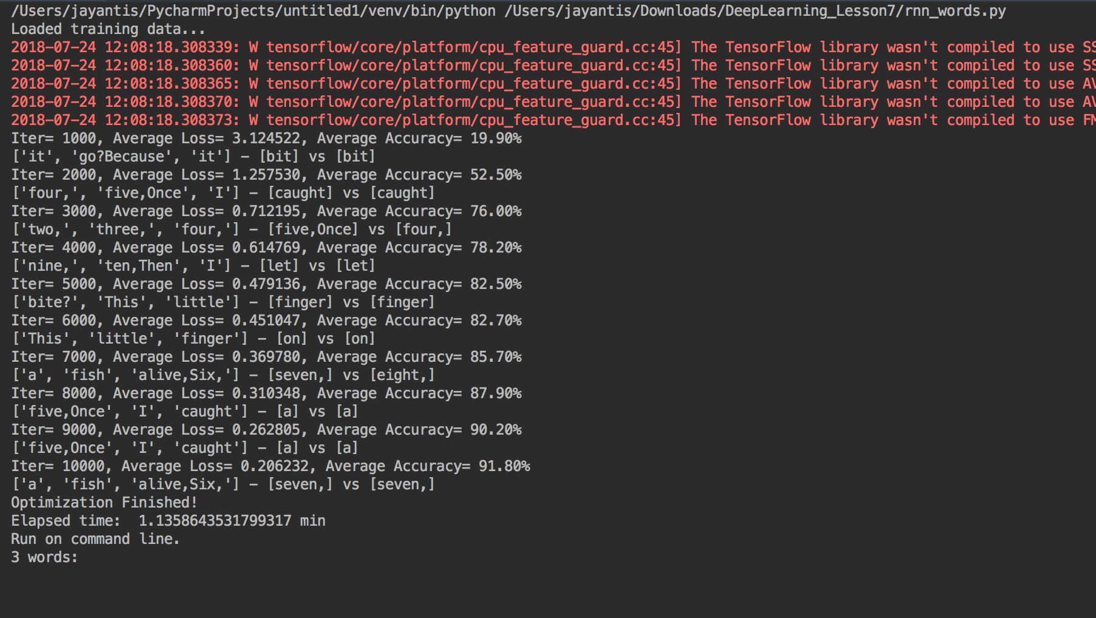

Optimizer:Adam

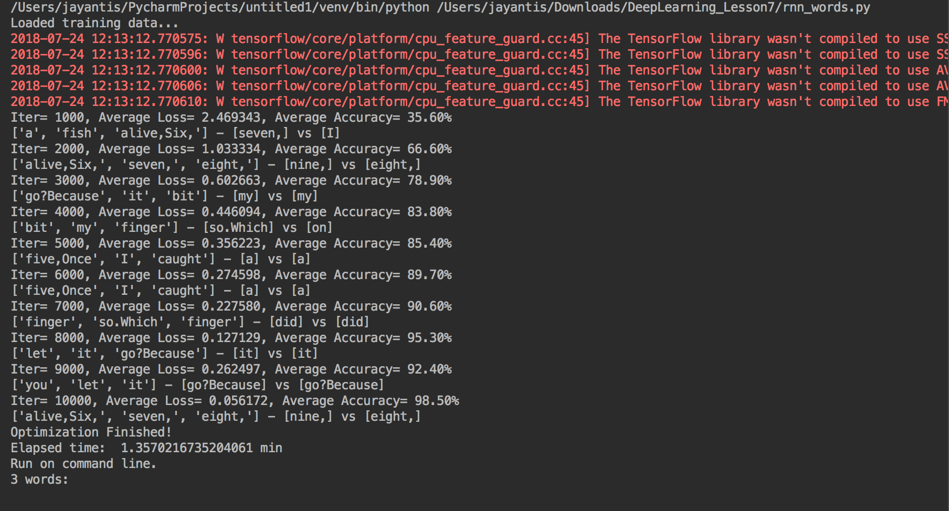

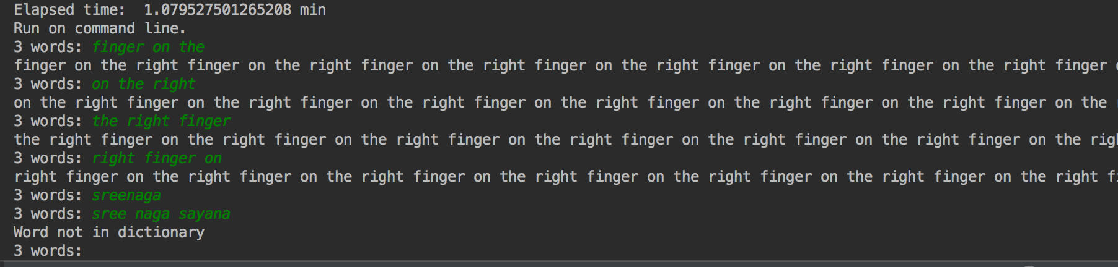

Optimizer:Adagrad

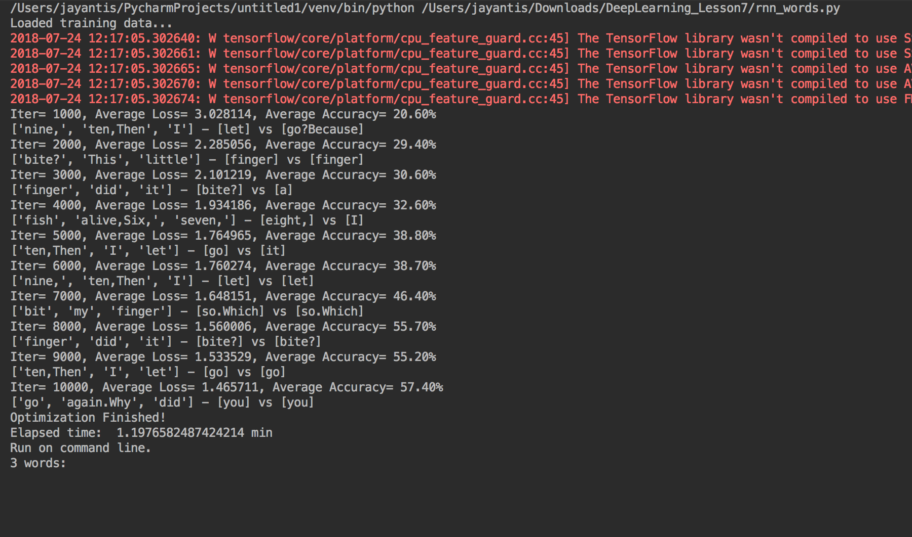

Optimizer: GradientDescent

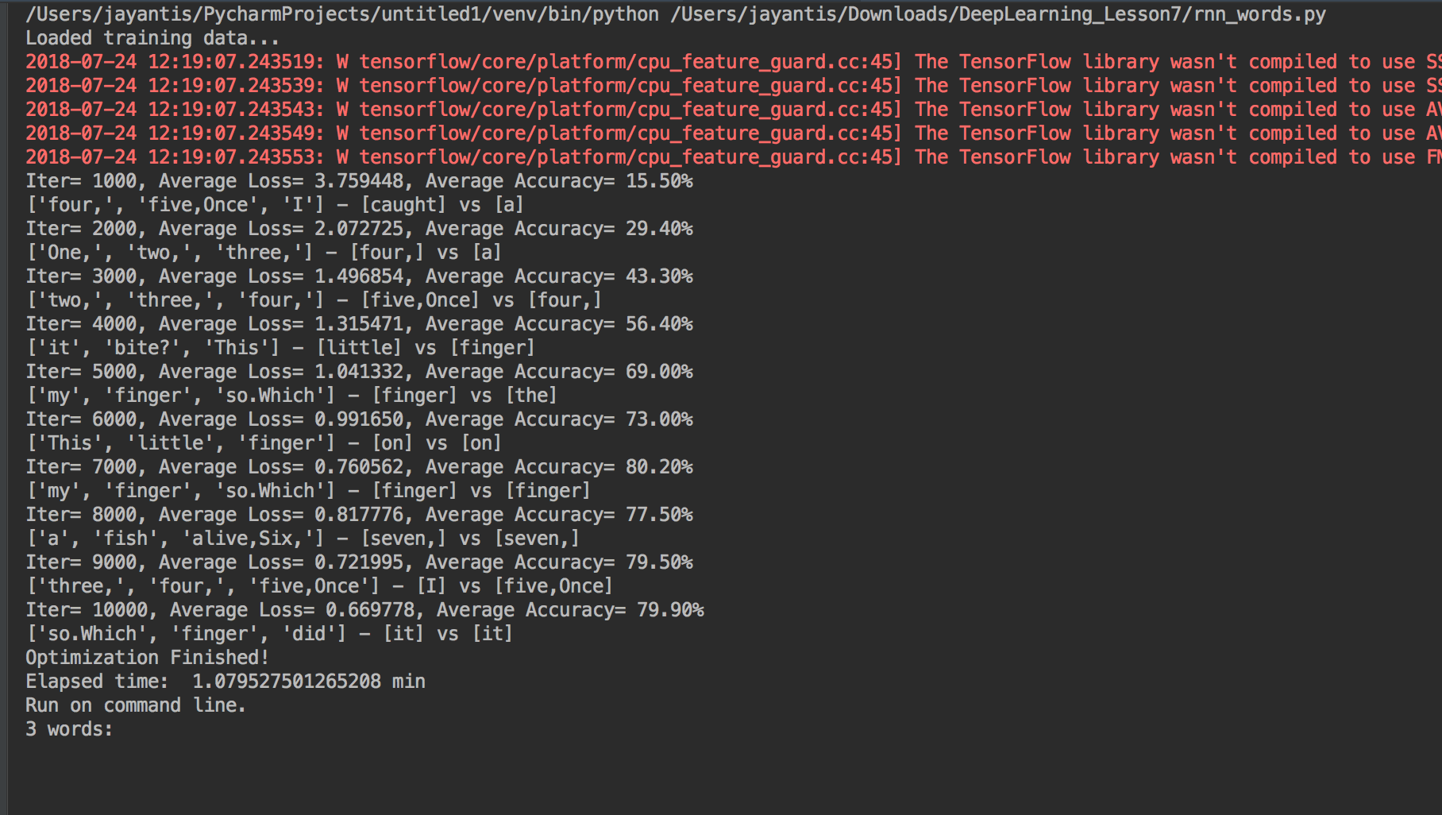

Changing the parameters:

Optimizer: Adamoptimizer

Learning rate = 0.1

Training_iters = 5000

Display_step = 1000

N_input = 4

N_hidden = 256

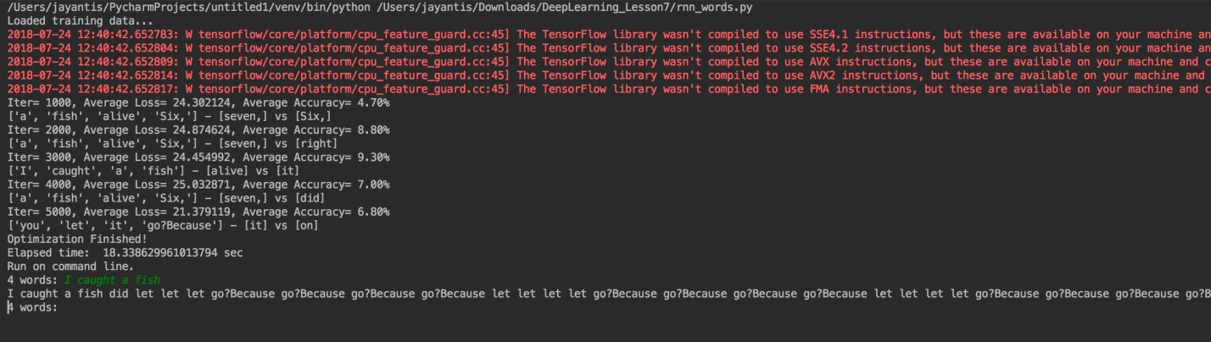

Optimizer: Adamoptimizer

Learning rate = 0.5

Training_iters = 5000

Display_step = 1000

N_input = 5

N_hidden = 1024

